**HyMOD_ Homework guide**

**Step-1: Installation of the Matlab software from OU-IT Store website**

**MATLAB Instructions for OU Students**

Create a MathWorks Account using your OU email: <https://www.mathworks.com/mwaccount/register>

Next, login to the **MathWorks License Center**: <https://www.mathworks.com/accesslogin/login.do?uri=%2Flicensecenter%2F>

Click the **Associate License** button in the upper right-hand corner.

Enter the following **Activation Key**: 12347-79186-66647-23391-05886

To download your software: <http://www.mathworks.com/downloads/web_downloads/select_release>

Click the **download** button for the current release, or select an earlier release, if needed.

Click the **installer** button to download the installer.

Locate the installer you downloaded in a file browser and start the installer:

**• Windows:** Double-click the installer file you downloaded in the previous step. The Windows Self-Extractor runs, and then the installer starts.

• **Mac OS X:** Double-click the installer file you downloaded in the previous step. This action extracts the files and creates another folder called **matlab__<release>_maci64,** Inside this folder, double-click **InstallForMacOSX** to start the installer.

In the MathWorks installer, select **Log in with a MathWorks Account** and follow the online instructions.

After downloading and installing your products, keep the **Activate MATLAB** checkbox selected and click **Next**.

When asked to provide a user name, verify that the displayed user name is correct. Continue with the process until activation is complete.

Step-2: Procedures to Running the HyMOD model

1. Extract HyMOD folder to desktop
2. From the list of folder components, click on Hymodmain.m
3. Click on the **Run** icon (seen in green color below) at the upper part of the screen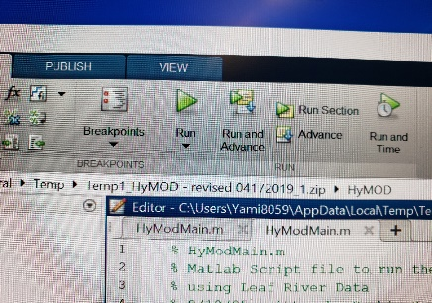 Figure 1
4. Under command window at the bottom of the screen:

>>Hymodmain, you will see the number of Days of data available as 14610

* Enter the first Day of the Simulation Period: E.g. 200 and click the **enter** button on keyboard
* Enter the last Day of the Simulation Period E.g. 600

5. Press enter again, and you will see the Matlab icon at the bottom of the screen (Fig 2)

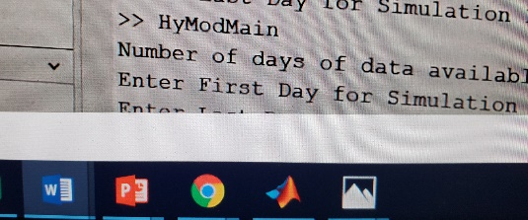 Figure 2

1. Click on the Matlab icon in (Fig 2) & you will see the results of the modeling work in Fig 3

* Check the Model indices Bias, RMSE and NSCE values so that you can change the first day and last day values to get the right values for model indices

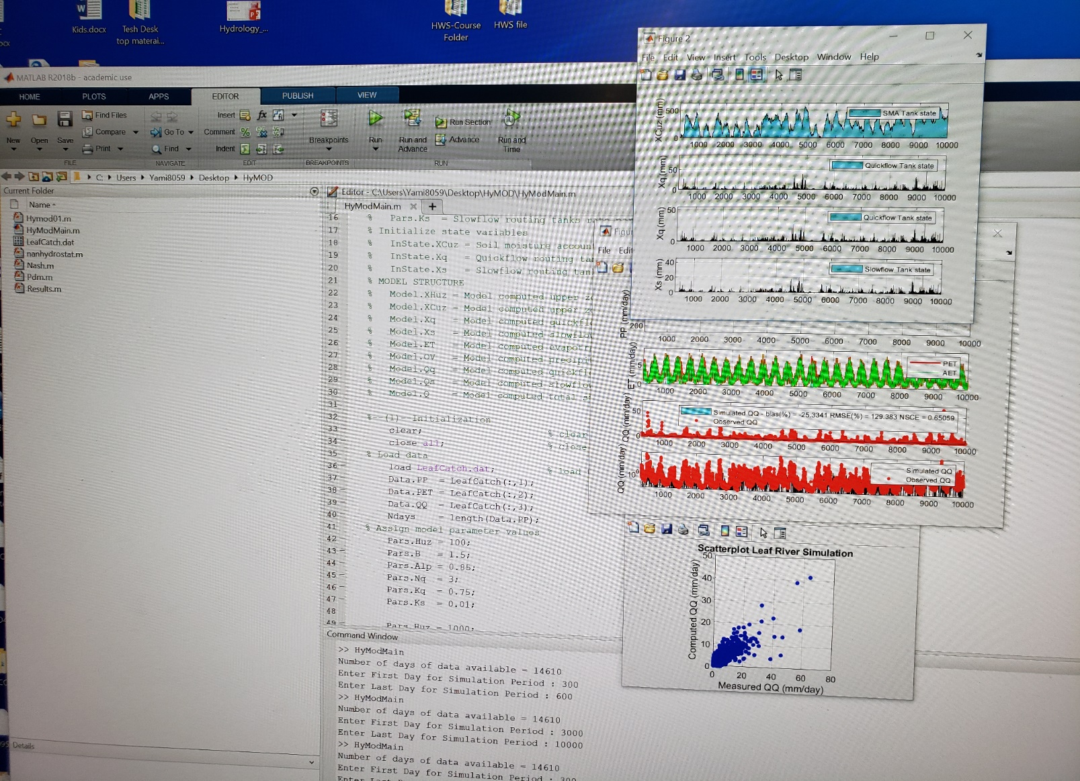Figure 3

1. Once you have all the figures, you can copy them to your answers.
2. Change one to two model parameters seen in Figure 4 below so that you can observe the results of the model. After changing the model parameters, you can write comment to display which parameters can affect the model results.

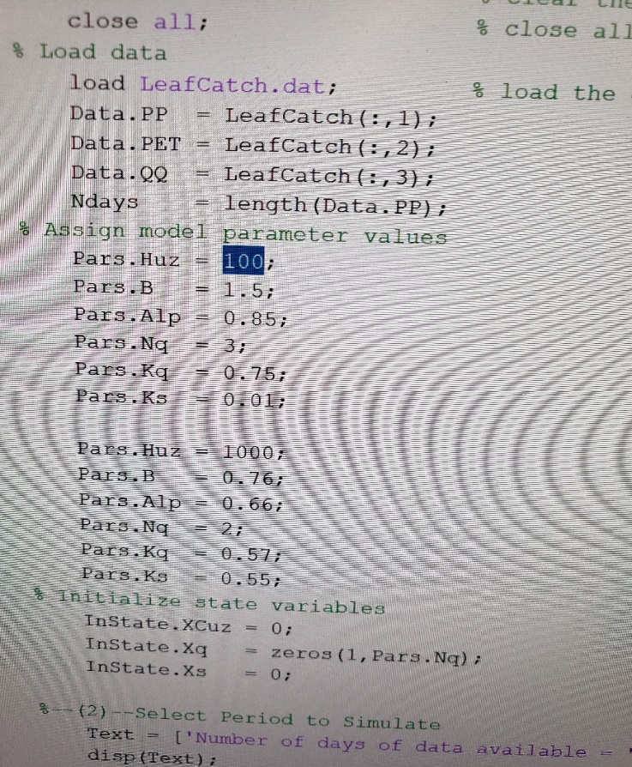

Figure 4

GOOD LUCK!!!